**INSTRUCTIONS TO AUTHORS FOR THE PREPARATION OF MANUSCRIPTS FOR WORLD MINING CONGRESS 2023**

*A.A. Surname1, B.B. Surname2, C.C. Surname3, D.D. Surname1

1Department of Mining Engineering, Brisbane University, Brisbane, Queensland, Australia

(*Presenting author: aasurname@brisbane.edu.au)

2Mining Technology Pty Ltd, Clayton, Victoria, Australia

3Mining Division, CSIRO, Brisbane, Queensland, Australia

**ABSTRACT**

The body of the abstract, not to exceed 500 words in length, in regular Times New Roman, fully justified, separated from the heading ABSTRACT by one (1) blank line and indented. The abstract is a single paragraph.

**KEYWORDS**

Instructions, authors, World Mining Congress

**1. FIRST LEVEL HEADING CENTRED**

Your manuscript must be submitted to our online peer-review management system. Manuscript should not exceed approximately 10 pages in length, including text, figures, tables, and references. Electronic file should not exceed 3 megabytes.

Authors are responsible for ensuring the accuracy of all information contained in their manuscripts (e.g., proper names of organizations, data and findings, references, etc.).

Manuscripts must be prepared in proper English. SI units or acceptable metric equivalents must be used throughout.

These instructions will enable you to prepare your manuscript in an electronic format, ready for submission and peer review. It is therefore essential that these instructions be carefully followed.

**2. PREPARATION OF THE MANUSCRIPT**

Prepare your manuscript using Microsoft (MS) Word for Windows as your word processing software. To ensure that your manuscript has an identical appearance when viewed on almost any computer, avoid the use of a two-byte code for Chinese characters, etc.

Text paragraphs are single-spaced (line height of 6 lines per inch) and fully justified, with the first line indented 1.27 cm (0.5 inch). Paragraphs are separated with a blank line.

**2.1 Second Level Heading to the Left**

Your manuscript must be prepared in European A4-size (210 x 297 mm) paper. Use the margin settings specified in Table 1 and do not number the pages of the paper.

Table 1 – Manuscript margins

|  |  |
| --- | --- |
| Margin | A4 (210 x 297 mm) |
| Top | 2.90 cm (1.14 inches) |
| Bottom | 4.60 cm (1.81 inches) |
| Left | 2.90 cm (1.14 inches) |
| Right | 2.90 cm (1.14 inches) |

2.1.1 Third-Level Heading Left

**Equations**

Simple mathematical expressions and sub- and super-scripted characters, such as SO42-, are inserted in the text. Do not embed equations as an image.

Equations are placed on separate lines, centred and numbered consecutively in parentheses at the right-hand margin. A blank line precedes and follows each equation.

**Figures**

All figures should be high resolution (300 dpi) when published at 100%. Figures including graphs, line drawings, photographs and other illustrations are preferably in colour. Any greyscale figures require sharp contrast. For all figures, lines and lettering must be large enough (minimum 0.35 point thickness) to remain clearly legible when printed at 100%. For maps, microstructures and similar figures, be sure to place a scale marker on the picture or photograph. Do not use frames around figures. Do not use shaded backgrounds as they do not reproduce well.

All figures must be consecutively numbered with Arabic numerals and inserted as close as possible to the corresponding text. A caption consisting of the word “Figure,” the figure number, a dash and the figure title, in 10 point Times New Roman, must appear centred below each figure. A single blank line is used to separate a figure from its caption.

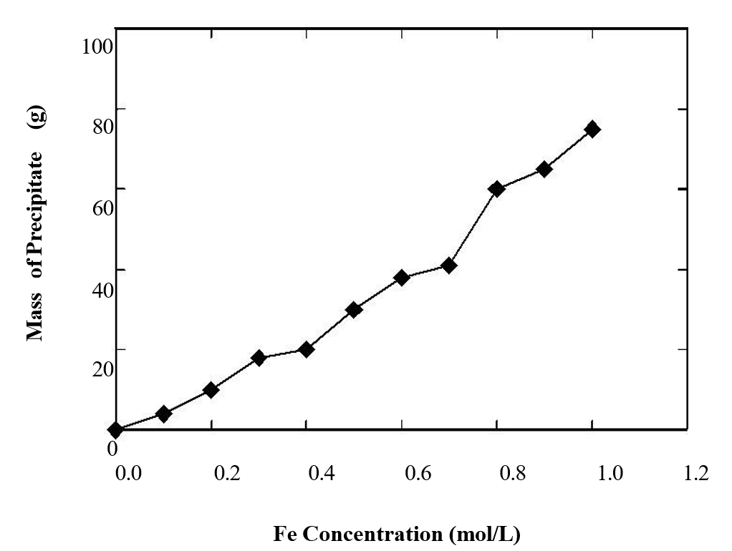

Figure 1 – Effect of iron concentration on the amount of precipitate formed during hydrolytic

precipitation from waste processing solutions

**Tables**

Insert tables as close as possible to their first citation. Number tables consecutively using Arabic numerals and centre the title above the table. The word “Table” is followed by the table number, a dash, and the rest of the title. There is no line space between the title and the table itself.

Table-wide lines (horizontal ½ point thickness) separate the title from the column headings, the column headings from the body of the table, and the table from the following text. Do not use vertical lines and avoid the use of horizontal lines between the various rows of data. Separate each table from the adjacent text with one (1) blank line.

Table 2 – Electron microprobe analyses of sphalerite grains in the Kidd Creek “C” concentrate

|  |  |  |
| --- | --- | --- |
| Element | Average Content | Range |
|  | (wt %) | (wt%) |
| Zn | 60.8 | 59.6 – 63.3 |
| Fe | 5.82 | 3.54 – 6.95 |
| Cd | 0.30 | 0.12 – 0.42 |
| S | 3.31 | 33.6 – 33.5 |

**ACKNOWLEDGEMENTS**

The authors can express their appreciation or acknowledge to support and help their received on their work etc.

**REFERENCES**

American Psychological Association (2009). *Publication Manual of the American Psychological Association (6th ed.)*. Washington, DC: Author.

Guo, H., Todhunter, C., Qu, Q. and Qin, Z., (2015). Longwall horizontal gas drainage through goaf pressure control. *International Journal of Coal Geology*. 150-151, 276-286.